**Name (netid):** Ruisen Tu (ruisent2)

**CS 445 - Project 5: Image Based Lighting**

Complete the claimed points and sections below.

**Total Points Claimed [ 100 ] / 250**

**Core**

1. Stitch two key frames [ 20 ] / 20
2. Panorama using five key frames [ 15 ] / 15
3. Map the video to the reference plane [ 15 ] / 15
4. Create background panorama [ 15 ] / 15
5. Create background movie [ 10 ] / 10
6. Create foreground movie [ 15 ] / 15
7. Quality of results and report [ 10 ] / 10

**B&W**

1. Insert unexpected object [ ] / 15
2. Process your own video [ ] / 20
3. Smooth blending [ ] / 30
4. Improved fg/bg videos [ ] / 40
5. Generate a wide video [ ] / 10
6. Remove camera shake [ ] / 20
7. Make streets more crowded [ ] / 15

**1. Stitch two key frames**

Include

* Display of image frames 270 and 450 with the red plot lines showing corresponding regions

frame 270 frame 450

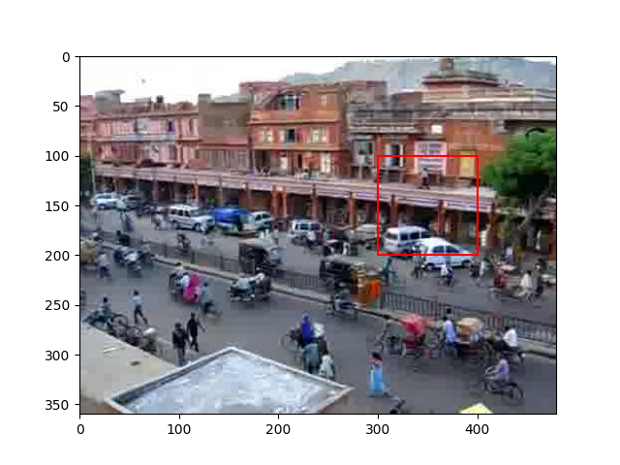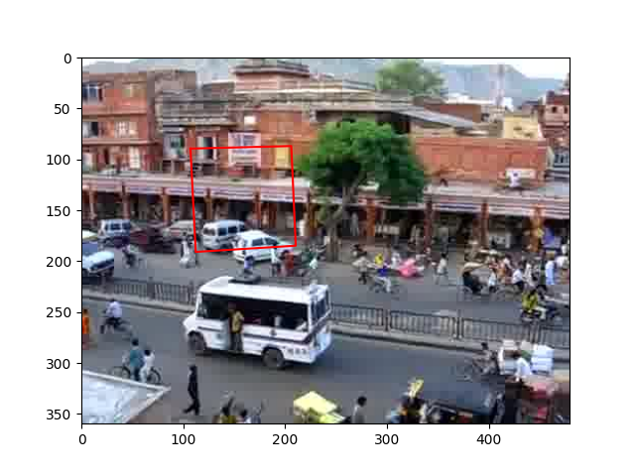

* Printout of 3x3 homography matrix normalized so that the largest value is 1

[[ 1.00000000e+00 5.53208568e-02 -2.05219375e+02]

[ 7.05586449e-03 9.63019973e-01 -1.46687656e+01]

[ 3.51022884e-04 6.09244563e-05 8.26075654e-01]]

**2. Panorama using five key frames**

Include your panoramic image

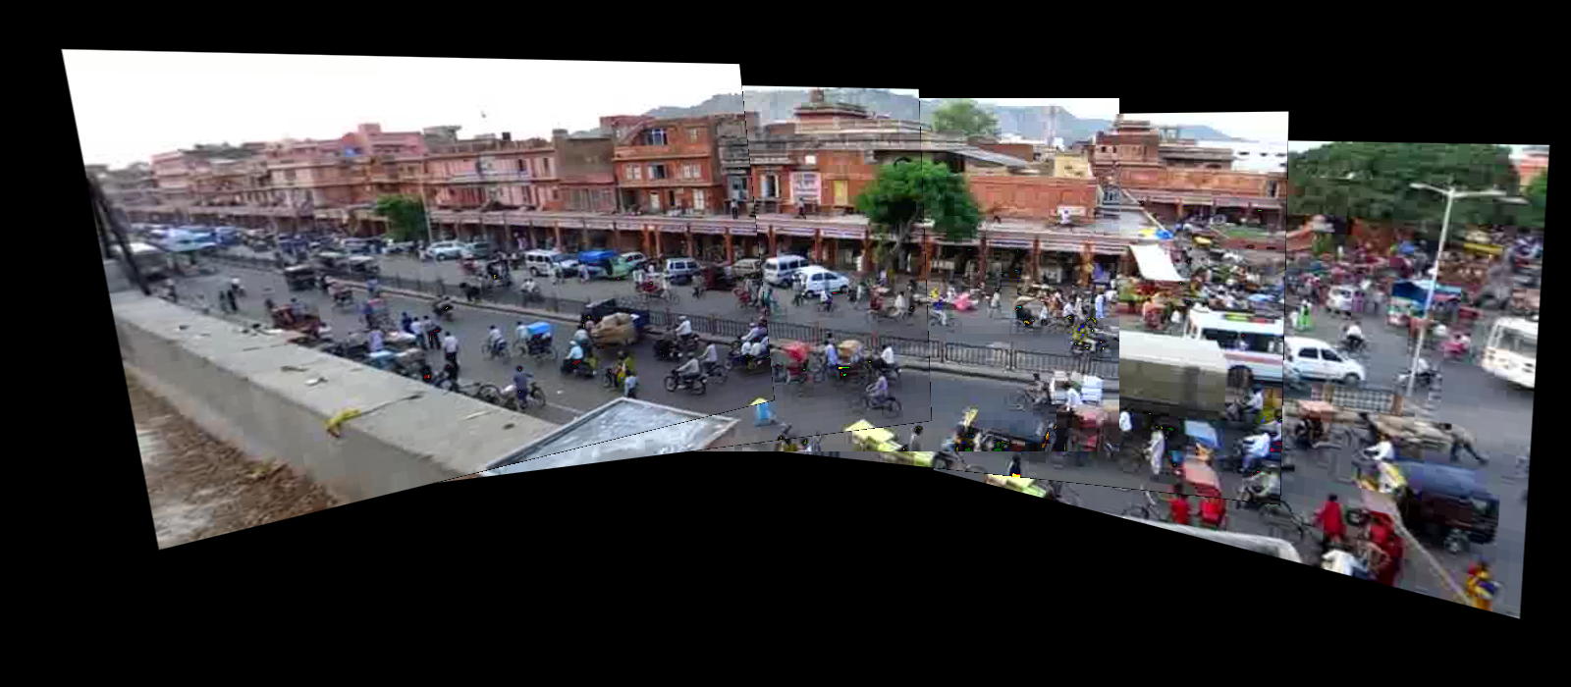

**3. Map the video to the reference plane**

Include:

* Link to your video
  + <https://www.youtube.com/watch?v=1u0niFjK0iU>
* Display frame 200 of your video

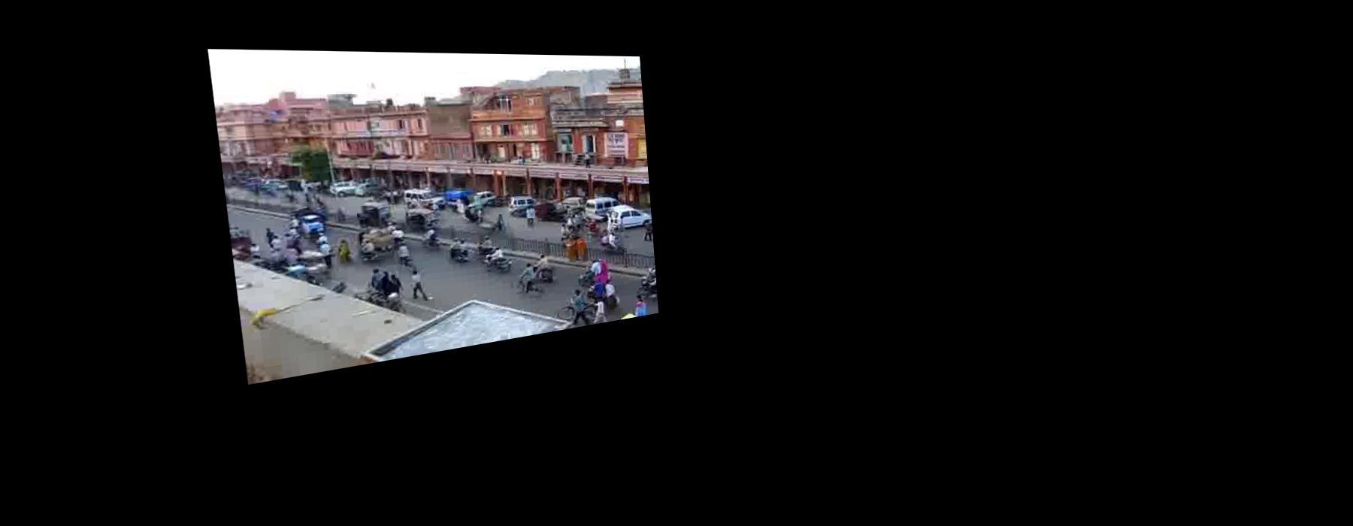

* Briefly explain how you solved for the transformation between each frame and the reference frame
  + I first find the key frame that is closest to the current frame , which makes sure that they have as large overlap as possible.
  + Then I calculate the homography matrix that maps frame to frame .
  + After that, given the homography matrix that maps frame to frame 450 (calculated in part 2) and the translation matrix , we can get the final homography matrix which maps frame to the reference frame 450.

**4. Create the background panorama**

Include:

* Picture of the background panorama

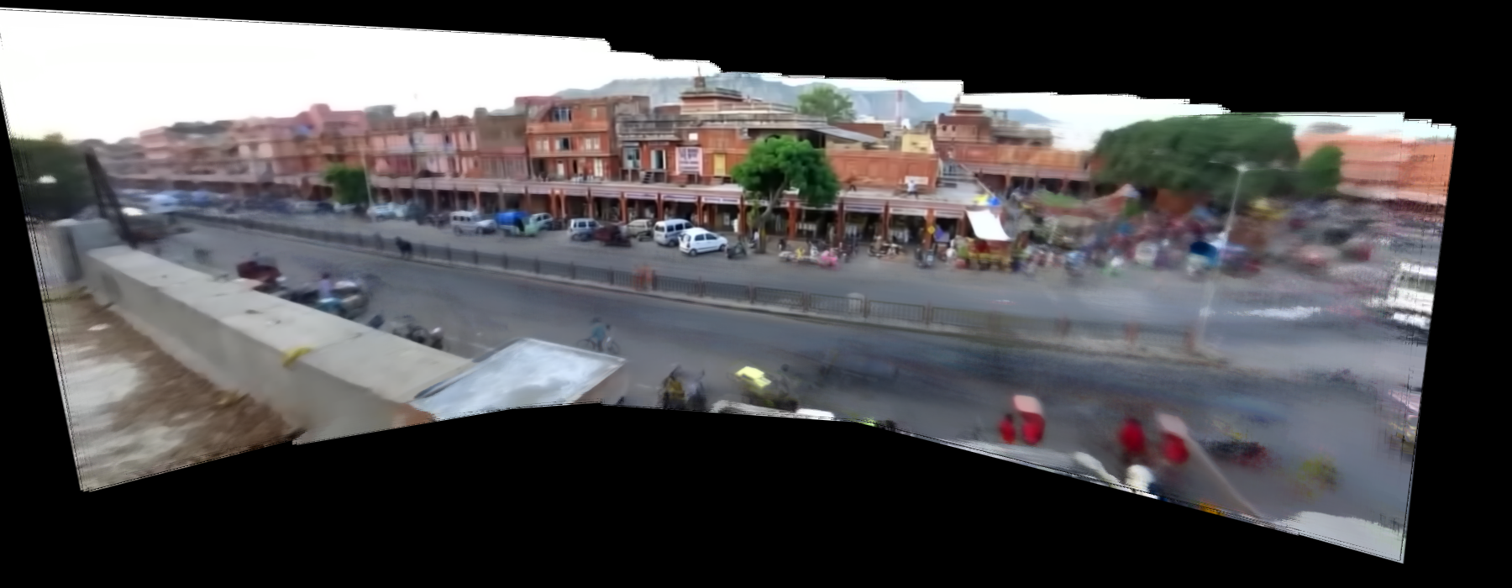

* Explain your method of computing the background color of a pixel
  + For each pixel in this panorama, I first gather all colors at this pixel from all 900 frames except black (0,0,0). Then, the final value of each channel at this pixel equals the **median** of values in the corresponding channel of all collected colors.

**5. Create the background movie**

Include:

* Link to your video
  + <https://youtu.be/bgEQJ7_qMGg>
* Display frame 200 of your video

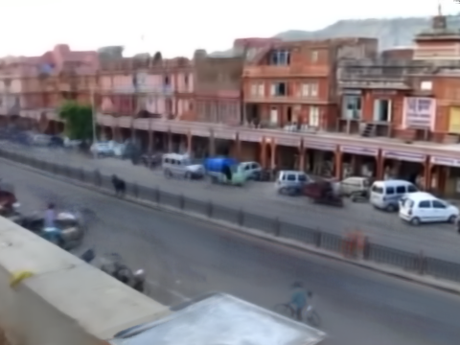

**6. Create the foreground movie**

Include:

* Link to your video
  + <https://youtu.be/xC1dIjGEw9M>
* Display frame 200 of your video

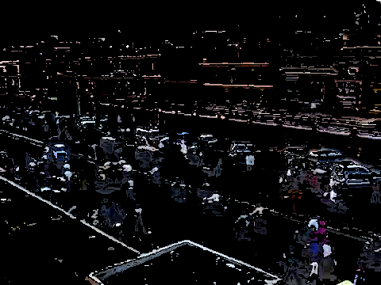

**7. Quality of results / report**

Nothing extra to include (scoring: 0=poor 5=average 10=great).

**8. Insert unexpected object**

Include link to your video.

**9. Process your own video**

Include:

* Background image
* Link to background video
* Link to foreground video

**10. Smooth blending**

Include panoramic image from part 2 with better blending

**11. Smooth blending**

Include panoramic image from part 2 with better blending

**12. Generate a wide video**

Include link to your video

**13. Remove camera shake**

Include link to your stabilized video

**14. Make street more crowded**

Include link to your video

**Acknowledgments / Attribution**

List any sources for code or images from outside sources